Part 2

Name: Chiu Ming Abraham Tsang

Title: CU Mobility

Project Summary: This project is intended to make the transport of CU as smooth as possible. Specifically, users report about any transportation problems they see, and the support team will fix it as soon as they see a problem.

Project Requirements:

|  |  |
| --- | --- |
| ID# | User Requirements |
| 001 | Login |
| 002 | Access GPS and camera |
| 003 | Show options |
| 004 | Report a problem and categorize what kind it is |
| 005 | Show map with all the problems |
| 006 | Get potential reward |

UI Mockups:

a.

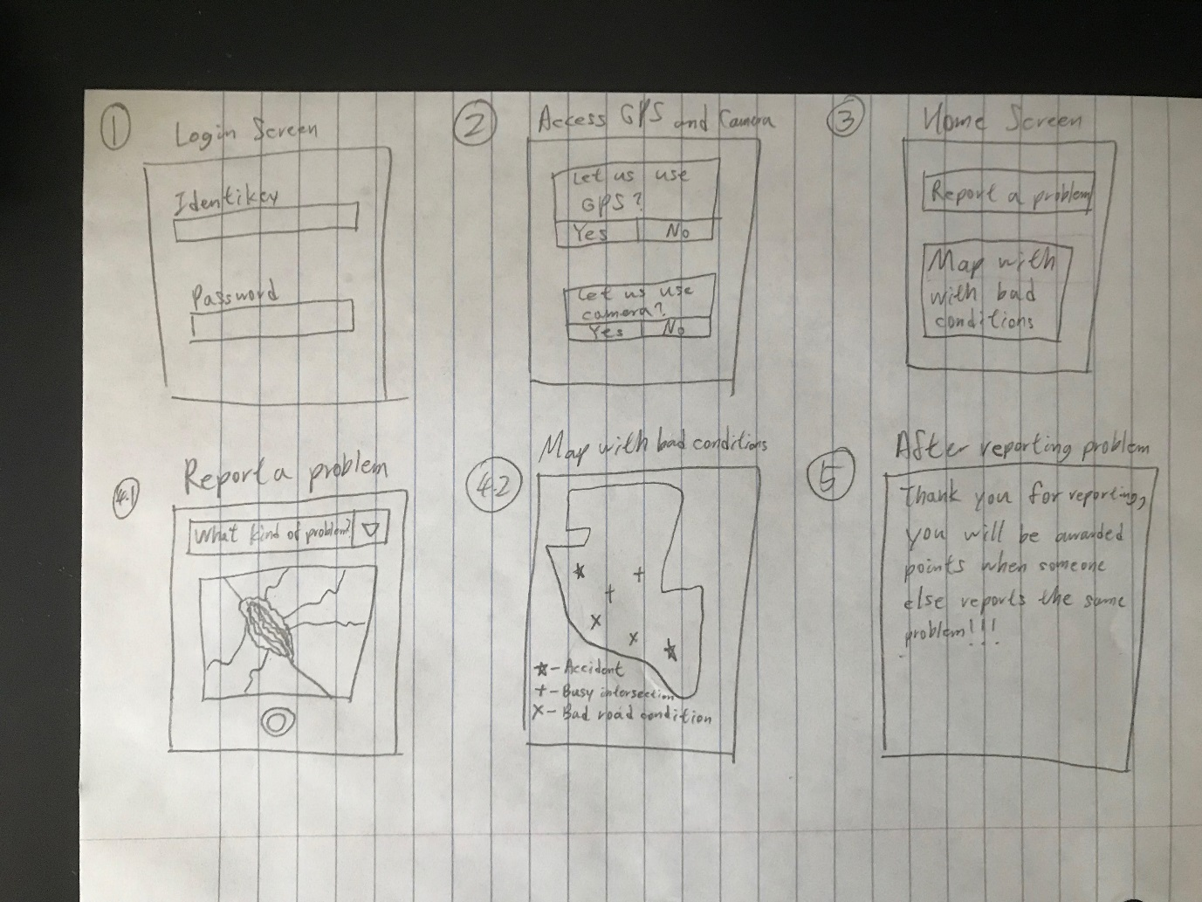

b. As you can see, the UI is simple as the user shouldn’t overthink it.

c. The main data to display here is the conditions in map, and so the positions of the conditions is displayed based on the coordinates of the students.

d. When an action is performed on one screen, it will automatically jump to another screen. E.g. Once all the login information is typed, it will jump to asking for permission for accessing GPS and camera.

Class Diagram: